MITOSIS WEBQUEST

Website #1: Introduction to Mitosis - http://plaza.ufl.edu/alallen/pgl/modules/rio/stingarees/module/what.html

Directions: As you read the information from this site answer the following question.

- What are the 2 reasons why cells undergo the process of MITOSIS?

1.____________________________________ 2. ___________________________________________

- True Or False – Elephant and human cells go through mitosis.

Website #2: The Stages of the Cell Cycle - http://www.biology.arizona.edu/cell_bio/tutorials/cell_cycle/cells3.html

Directions:

- Draw and label a picture of the cell during each stage; include color

- List what is happening during each event of the Cell Cycle

INTERPHASE

B.
A.

PROPHASE

B.
A.

PROMETAPHASE

B.
A.

METAPHASE

B.
A.

ANAPHASE

B.
A.

TELOPHASE

B.
A.

CYTOKINESIS-

B.
A.

1. How is cytokinesis different in animal and plant cells? ________________________________________________

______________________________________________________________________________________________

______________________________________________________________________________________________

Website #3: Stages of Mitosis - http://www.cellsalive.com/mitosis.htm

Directions: Click START THE ANIMATION and watch the animation.

- We start with __________ cell and we end with _____________ cells

- List the stages of mitosis (Notice – there’s an extra phase here…”prometaphase” – sometimes that is added as an “in-between” phase between prophase and metaphase. In my class you are only responsible for knowing PMAT)

- __________________________

- __________________________

- __________________________

- __________________________

- Go back to the main page and read “Events during Mitosis.”
- Then answer, in which stage does each of the following occur:
Chromatin condenses into chromosomes
Chromosomes align in center of cell.
Longest part of the cell cycle.
Nuclear envelope breaks down.
Cell is cleaved into two new daughter cells.
Daughter chromosomes arrive at the poles.

- Identify the stages of mitosis in these cells:

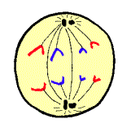 | 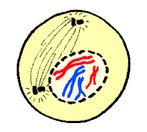 | 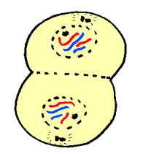 | 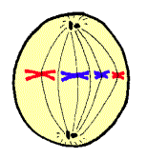

Website #4: Mitosis and Cytokinesis Animation: http://media.pearsoncmg.com/bc/bc_campbell_biology_7/media/interactivemedia/activities/load.html?12&C

Directions: Read the description and watch the animation on each of the 10 pages

- Cell division consists of two processes: _____________ and _______________.
- Mitosis— division of the ___________________ and its chromosomes
- Mitosis is followed by cytokinesis, when the ___________________ splits to form two separate daughter cells
Click Next on the upper right side of the screen and watch the animation. (page 2 of 10)
Click Next again. (page 3 of 10)
- During prophase, the nucleoli disappear and chromatin fibers coil up to become discrete _________________.
- Each chromosome consists of two identical sister ________________, joined at the centromere.
Click Next 3 times (page 6 of 10)
- Anaphase begins when the two centromeres of each chromosome come _______________,
separating the _________________ __________________.
- Once separate, each sister chromatid is considered a full-fledged daughter chromosome.
Click Next again (page 7 of 10)
- During telophase, ______________ ________________ form around the identical sets of chromosomes
at the two poles of the cell. The chromosomes uncoil and nucleoli appear in the two new nuclei.
- Meanwhile, ____________________ begins, splitting the cytoplasm and separating the two daughter cells.
Click Next again (page 8 of 10)
- In animal cells, cytokinesis begins with the formation of a _______________ _________________.
- At the site of the furrow, a ring of microfilaments contracts, much like the pulling of drawstrings.
- The cell is pinched in two, creating two _____________________ daughter cells.
Click Next again (page 9 of 10)
- In plant cells, cytokinesis begins when vesicles containing cell-wall material collect in the middle of the cell.
- The vesicles fuse, forming a large sac called the ____________ ______________.
Click Next again (page 10 of 10)
- Complete the activity, then complete the chart below
- Write the correct order of the cell cycle. (You do not need to include Prometaphase)
(Prophase, Interphase, Anaphase, Cytokinesis, Metaphase, Telophase)
  - ____________________________________________
  - ____________________________________________
  - ____________________________________________
  - ____________________________________________
  - ____________________________________________
  - ____________________________________________

