Photosynthesis Pre-Lab Review

- Plants use photosynthesis to make __________________ for the plant.

- What do plants need in order to perform photosynthesis?

- How is the plant able to obtain each “ingredient?”

- Identify the plant cell organelle in which photosynthesis takes place.

- Summarize the process of photosynthesis.
- Water and carbon enter the chloroplast…..

- What happens to the oxygen that is produced as a result of photosynthesis?

- Why is photosynthesis also important for people and animals?

Virtual Lab #1 - http://www.reading.ac.uk/virtualexperiments/ves/preloader-photosynthesis-full.html
Bubbles are given off by the plant through photosynthesis. By measuring the rate at which the bubbles are produced it is possible to tell how fast the plant is photosynthesizing.

In this virtual lab, you will be answering the following: Question: How does the light intensity (distance of light from plant) affect the rate of photosynthesis on Elodea (freshwater plant)?

a. Read and follow the directions on how to use this lab simulator.

Write a hypothesis for your prediction below.
Hypothesis (if/then/because): __________________________________________________________________

__________________________________________________________________________________________

b. Using the distances below, drag the light source to the first distance and press start and record the bubbles per minute for each of the following light distances. * Collect data for a min. of 30 sec.

c. Then graph your data. Be sure to label the axes!
Bubbles per minute

Light Distance (cm)

100

120

150

180

200

Y Axis

X Axis

8. Based on your data, write a conclusion regarding how light intensity affects the rate of photosynthesis. (Restate the hypothesis; supported or not; cite data; interpret data; no need to say how it could be improved)
__________________________________________________________________________________________
__________________________________________________________________________________________
__________________________________________________________________________________________
__________________________________________________________________________________________
Virtual Lab #2 - http://www.kscience.co.uk/animations/photolab.swf
In this lab, you will be experimenting with how different variables affect the rate of photosynthesis.
Directions
- Set the thermometer to 25°C (Room Temperature) and the light intensity to 20.
  - Record the bubbles per minute at this setting on your data table, track for a min. of 30 seconds.
  - Check with two other students at your table and record their data and calculate the average.

- Now increase the CO₂ available to the elodea, leaving temperature and light intensity the same.
  - Record the bubbles per minute at this setting on your data table, track for a min. of 30 seconds.
  - Check with two other students at your table and record their data and calculate the average.
  - Answer question #9 below table on the next page.

- Keep your settings of light intensity of 20, increased CO₂ but increase the temperature to 40°C.
  - Record the bubbles per minute at this setting on your data table, track for a min. of 30 seconds.
  - Check with two other students at your table and record their data and calculate the average.
  - Answer question #10 below table on the next page.

- Keep your settings of light intensity of 20, increased CO₂, but decrease the temperature to 10°C.
  - Record the bubbles per minute at this setting on your data table, track for a min. of 30 seconds.
  - Check with two other students at your table and record their data and calculate the average.
  - Answer question #11 below table on the next page.

- Alter the variables in order to determine which combination leads to the highest rate of photosynthesis.
- List your combinations (with specific settings and numbers below)
- Record you final results in #12 on the next page.

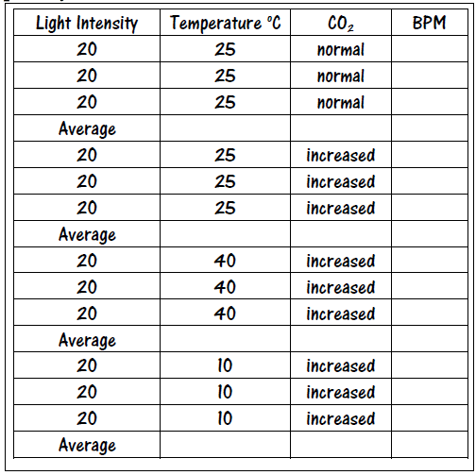
Data Table #1

Results
    - Based on your data, how does the amount of available CO₂ affect the rate of photosynthesis?

    - Based on your data, how does an increase in temperature affect the rate of photosynthesis?

    - Based on your data, how does a decrease in temperature affect the rate of photosynthesis?

    - Which combination of settings produced the highest number of bubbles per minute?

- Temperature: __________
- Light: __________
- CO₂: __________

    - Write the chemical equation for photosynthesis.

