Name: _________________________________ Date: _______________ Block: 1 2 3 4

Protein Synthesis Virtual Lab

Part 1:
Go to the following website and answer the questions below.
https://store.lab-aids.com/high-school-curriculum/simulations/genetics_act16_sim.html

- Click start on the homepage.
- What is the first stage of making a protein? ____________________________
- Where is the code found to instruct the cell on how to make mRNA? _____________________
- mRNA is made out of _____________________________. (Hint: Monomer of nucleic acids.)
- Transcription takes place in the __________________________ of the cell.
- Click continue
- What nitrogen base is found in RNA, but is not found in DNA? ____________________
- Click continue
- Explain the base pairing rules followed in the simulation to produce the mRNA.
______________________ pairs with _____________________
______________________ pairs with _____________________
- What is the job of RNA polymerase?
- What happens when the mRNA strand is complete?
- Label the diagram below:
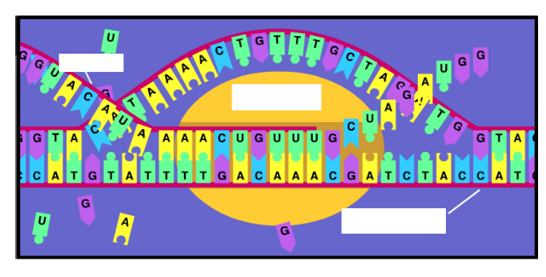
- Click continue
- Once transcription is complete, the new ________________ strand leaves the ___________________________and moves into the _________________________ where it will participate in the next phase of ___________________________________.
- Click continue
- Where does translation occur? _________________________________________
- What provides the template for the sequence of amino acids? _____________________
- What is a codon and where is it found?
- What is the anti-codon and where is it found?
- Click continue
- The anti-codon of the tRNA match with a specific codon of mRNA to create what? ____________________________________
- Label the diagram
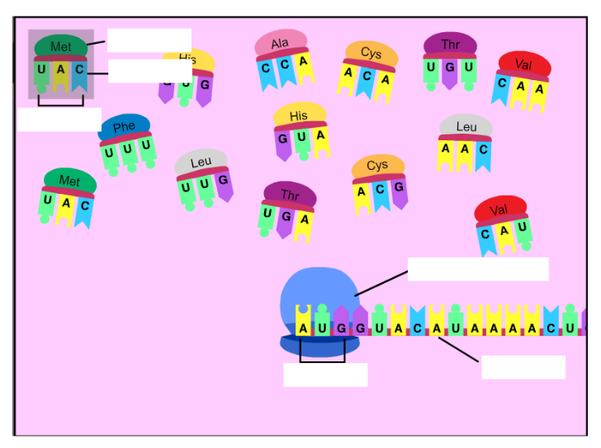
- Write the amino acid sequence below:

- The final product of this process is what? __________________________________
- What determines the function of the protein?

- Move on to part 2

Part 2:
Go to the following website and answer the questions below.
https://learn.genetics.utah.edu/content/basics/transcribe/

- Click to begin
- DNA is __________________________________ stranded.
- When transcription starts, the DNA strands separate to allow the ___________________ to make a copy.
- Fill in the RNA strand below:

- After ____________________________ is complete, the DNA strands reconnect.
- What is the next step? ___________________________________
- Click on the start codon AUG.
- Fill in the corresponding amino acids:

___________ ___________ ___________ ___________ ____________ ___________

- What is the stop codon? ___________________
- What is the result of this process? ___________________________________________

